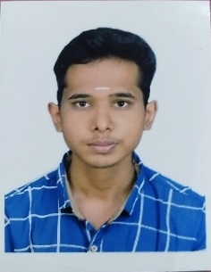ARUNKUMAR K

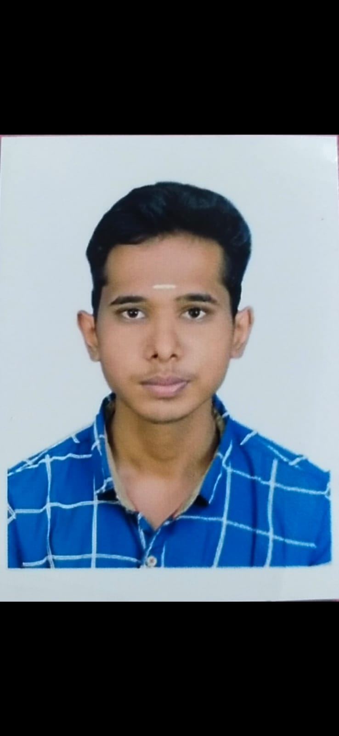

Address: F8, Durga illam, Bhavani nagar 1st street, Tiruppur-641607

Email Id: cecsarunkumark25@gmail.com

LinkedIn Id: https://www.linkedin.com/in/arunkumar-k-905785623

GitHub: https://github.com/ArunkumarK2003

Mobile No:9025840924

CAREER OBJECTIVE:

To work in a challenging and dynamic environment and to keep adding value to the organization that I represent and serve,while also concurrently upgrading my skills and knowledge

EDUCATION QUALIFICATION:

|  |  |  |  |
| --- | --- | --- | --- |
| COURSE | INSTITUTE/UNIVERSITY | YEAR OF | PERCENTAGE/CGPA |
|  |  | PASSING |  |
| B.E(Computer | K.S.R.College of Engineering | 2025(pursuing) | 7.4(CGPA UP TO 4th Sem) |
| Science and | Tiruchengode,Namakkal |  |  |
| Engineering |  |  |  |
| HSC | Kongu Matric. Hr. Sec. School | 2021 | 81.5 |
|  |  |  |  |
|  |  |  |  |
| SSLC | Kongu Matric. Hr. Sec. School | 2019 | 75.8 |
|  |  |  |  |
|  |  |  |  |

TECHNICAL SKILLS:

* Programming Languages: Java
* Fronted Languages: HTML ,CSS ,JAVASCRIPT
* Database Languages: SQL

AREA OF INTEREST:

* Web Development
* Database Management

PERSONAL TRAITS:

* Leadership Quality
* Flexible to environment
* Logical Thinking

MINI PROJECTS:

Title: MCQ Evaluation Tool(on going)

Description: Importing Question, automatic answer key, real-time grading and reducing evaluation Time

PERSONAL PROJECT:

Title: Personal Portfolio

Description: Show my experience, capability and potential for employment and professional development

CERTIFICATES:

* Certification on java in Sololearn-2023
* Certificate on HTML & CSS in GreatLearning-2023
* Completed and secured Elite Score in a 12 week Cloud Computing in NPTEL on November-2023

CO-CURRICULAR ACTIVITIES:

* Paper presentation in National level symposium contest at Erode Sengunthar Engineering College ;Topic: Robotics and Automation

EXTRA CURRICULAR ACTIVITIES:

* Participated in mobile photography in the Media Club event held at KSR College of Engineering

PERSONAL INFORMATION:

Father’s Name: KANNAN AT

Mother’s Name: LAKSHMI K

Date of Birth: 19-08-2003

Nationality: Indian

Gender: Male

Language Know: Tamil ,English

DECLARATION:

I here by declare that the details above are correct and true to the best of my knowledge

Date:

Place:

Yours truly,

(ARUNKUMAR K)